HINDUISM - Chapters
- When and Where Did Hinduism Begin?
- Top 20 Hinduism Facts for Kids
- What Are the Main Beliefs of Hinduism?
- Who Are the Hindu Gods?
- What Are Some Hindu Celebrations and Festivals?
- Where Are the Hindu Holy Places?
- Hinduism: Story of Rama and Sita
- Hinduism Activities

When and Where Did Hinduism Begin?

When did Hinduism begin?
Hinduism is one of the oldest religions in the world, and it is believed that Hinduism began as far back as 1500 BC! There are signs of important Hindu figures and deities such as Vishnu, Shiva and Devi in artefacts and architecture uncovered from between 500 BC and 500 AD, so we know some form of Hinduism was around at this time.
Today, it's believed over 900 million people follow Hinduism, most of these people live in India.

Where did Hinduism begin?
Although its origins are unclear, it seems to be a mix of different beliefs, cultures and traditions of the people who lived along the Indus River in South East Asia, near modern-day Pakistan. Hinduism is sometimes referred to as a way of life as it combines many different traditions and religious beliefs. Where Hinduism began is of little importance to Hindus, who believe that their faith is timeless.
The Hinduism Creation Story
For Hindus, there are periodic cycles of creation rather than one creation, this means that Hinduism has many creation stories.
One story is that before time began, there was no heaven, no earth and no space in between. In this nothingness, a cobra floated with Vishnu asleep wrapped in its coils. A magnificent lotus flower grew from his navel. In the middle of the lotus flower sat Brahma. Vishnu commanded that Brahma create the world. Brahma split the lotus flower into three: the earth, the sky and the heavens. He then created the plants and animals.

20 Facts About Hinduism for Kids

What are some interesting facts about Hinduism?
If you've enjoyed reading about Hinduism, why not use this handy Hinduism fact file to learn some fun facts about Hinduism? See how many Hindu facts you can memorize and impress your family and friends!
1. To kick off our Hinduism fun facts, did you know Hinduism is the world's third-largest religion after Christianity and Islam?
2. Another interesting fact about Hinduism, 90% of Hindus live in India!
3. Two other religions have originated from Hinduism: Sikhism and Buddhism.
4. Worldwide, there are over 1.1 billion Hindus - that's around 16% of the global population!
5. Nature is very important to Hindus and many believe that some rivers are sacred and can help you wash away sins. The River Ganges is a river in India that many Hindus believe is sacred.
6. Most Hindus are vegetarian because it minimizes the harm caused to other life forms. Some Hindus also believed a vegetarian diet purifies the body and mind.
7. While there are Hindu temples, many Hindu households have an area of their house that they also use to worship; this is known as a 'shrine'. Hindu places of worship are called mandir.
8. In 2013, 30 million Hindus celebrated Kumbh Mela, which is a special pilgrimage that only happens every 12 years. This meant it was the largest gathering of humans ever witnessed!
9. Unlike Christianity and Islam, Hinduism doesn't have a singular holy book but instead has many ancient texts and scriptures.
10. Hinduism is one of the oldest religions in the world - some Hindu traditions started over 3000 years ago!
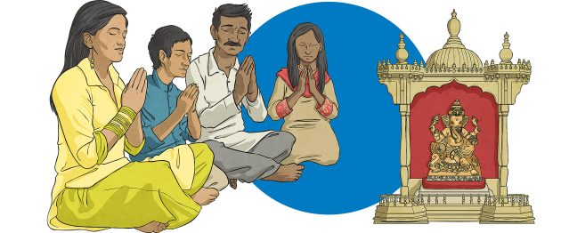
11. In Hinduism the supreme God is called 'Brahman'. All other gods worshipped by Hindus are believed to be a different part of Brahman.
12. A mooo-st know fun fact about Hinduism - cows are considered sacred by Hindus.
13. Hindu temples around the world always have an orange flag outside, even if they look slightly different.
14. In Hinduism, worship is called Puja.
15. The god Ganesh is a good luck symbol for Hindus; he is a god with the body of a man and the head of an elephant. Many Hindus will pray to Ganesh when they're starting something new!
16. Because the Hindu religion is so old, people aren't sure of its origins or who started it!
17. Many Hindus believe in something called karma. This is the belief that everything a person experiences in their current life is because of their actions in a past life.
18. An important symbol in Hinduism is the 'Om' or 'Aum'. It is also said by some Hindus three times before chanting prayers.
19. Only a few Hindusim facts left! Hindus refer to their religion as Sanātana Dharma which means 'the eternal law' or 'eternal teaching'.
20. During Diwali, Hindus draw beautiful patterns called 'rangoli'. Rangoli are made using powders made from colourful flowers and Hindus place them at the entrance of their homes to welcome gods and bring good luck. Take a look at this fun colouring activity where you can use your new knowledge of Hinduism fun facts to create and colour in your own rangoli:
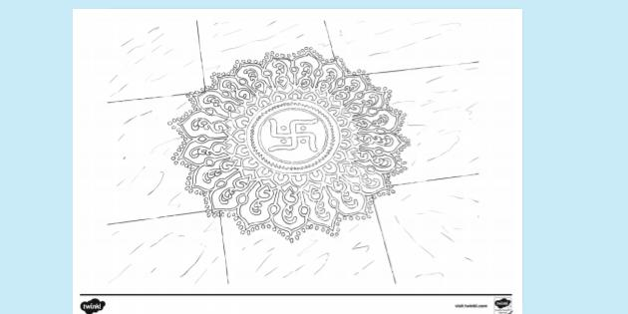

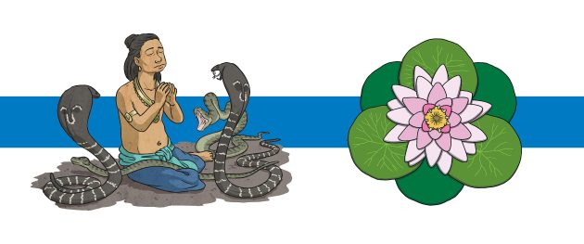
These beautifully illustrated story cards on the Hinduism Creation Story cover when Hinduism began and where Hinduism began according to Hindu beliefs. They might help you visualise and remember the origins of Hinduism, and they're fun to look at!
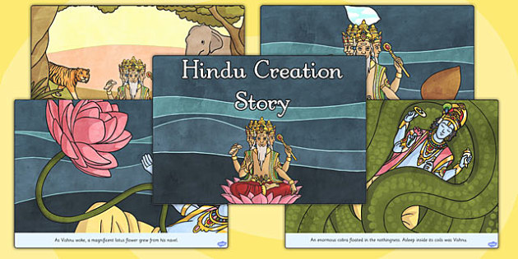
Hindu Creation Story

What Are the Main Beliefs of Hinduism?
Hinduism embraces many different traditions and practices. It has many beliefs and ideas and there is no one way to be a Hindu. However, there are four main beliefs that all Hindus share:
- Truth is eternal - Hindus believe there is only one eternal truth when it comes to existence and reality.
- Dharma - Dharma is quite complicated. It means that a Hindu must follow the moral law (and not just what you feel like doing) and take their duties seriously.
- Reincarnation - Reincarnation is the belief that a soul exists in the body and when a living thing dies it enters a new living thing. Hindus also believe that Karma (good and bad actions committed during your life) will affect which living thing the soul will be reborn into. For example, if you have bad Karma during your life you will be reborn as an animal rather than a human.
- Moksha - Moksha means that the soul will be released from the cycle of death and rebirth. The ultimate goal for all Hindus is Moksha.
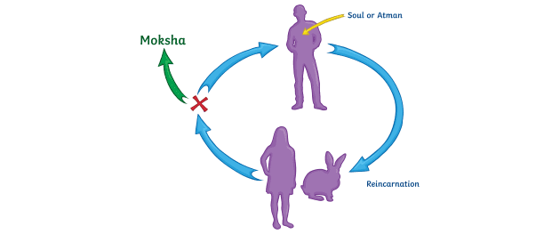

Who Are the Hindu Gods?
Hindus believe in one supreme god, but have many deities (gods and goddesses). Hindus worship one or more of the deities - it doesn't matter which, as they are all seen as different aspects of the one supreme god.
Hindus believe that there are three great gods (Māhadevas) also called the Trimurti (the three aspects of the universal supreme God). These three gods are:
- Vishnu - The god of preservation and protection. Hindus believe that he returns to earth during troubled times to restore the balance between good and evil.
- Brahma - The god of creation. He has four arms and four faces, looking in the four directions.
- Shiva - Shiva is the god of destruction. His role is to destroy the universe in order to recreate it. He is often shown with a third eye (which represents wisdom and insight).
The Tridevi are goddesses who are equally important. These three goddesses are:
- Saraswati - Saraswati is the goddess (Devi) of knowledge and the arts. She is often shown with a swan or peacock.
- Lakshmi - Lakshmi is the goddess of wealth and purity. Hindus believe that she can bless them with fortune and success.
- Shakti - Shakti is the mother goddess and is the source of all energy, power and creativity in the universe.
Other Hindu deities (gods and goddesses) include:
- Ganesha - Ganesha is the son of Parvati and Shiva. Hindus believe he can bless them with wisdom and good fortune. He has an elephant's head and a human body.
- Vayu - Vayu is the god of air/wind. He is also considered the god of life.
- Indra - Indra is the God of Heaven. He is often shown carrying a lightning bolt.
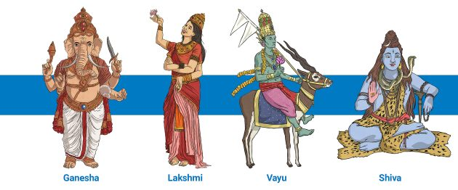
If you've enjoyed learning more about the Hindu gods, why not get creative with these fun colouring sheets? They're completely free to download and print at home!
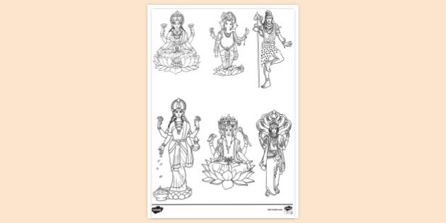
Hindu Gods Printable Colouring Page

Or to learn more about the Hindu values and what each of the Hindu gods teach, take a look at this interesting PowerPoint.
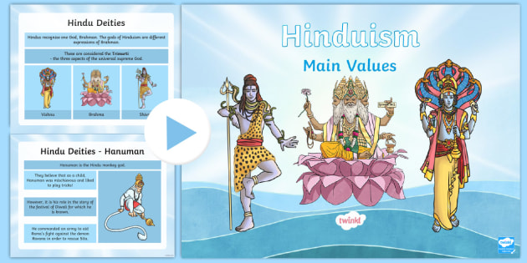
Hinduism Main Values PowerPoint

Hindus celebrate many special days and festivals throughout the year including:
- Holi - Holi is also known as the festival of colours. Hindus often celebrate in the streets by throwing colourful powders. Each colour has a different meaning, for example, green represents love. Holi marks the beginning of spring, usually in March and celebrates new life.
- Navaratri - Navaratri means 'nine nights' because this festival has nine nights of feasts and special dances. Navaratri is celebrated in late September or early October. Hindus worship and pray to the Goddess Durga as they believe that she will bless, protect and take care of those who worship her.
- Diwali - Diwali is known as the 'festival of lights' and celebrates the new year. It is celebrated in late October or early November. Diwali is a time for celebrating good over evil and happiness. Hindus celebrate by enjoying special meals with their families, exchanging gifts, lighting diva lamps and having huge firework displays.
Learn all about how people celebrate Diwali in this video for kids from our Youtube channel!
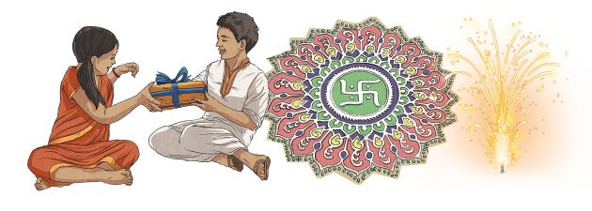

Where Are the Hindu Holy Places?
Where do Hindus worship? This chapter will help you to answer that question and explain why these places are so important to the Hindu faith.

Where do Hindus worship?
A mandir is a Hindu place of worship. Mandirs are seen as a place where heaven meets the earth, so many mandirs are tall buildings, reaching up into the sky. Inside the mandir is the main shrine and the Vedas (ancient Hindu texts).
Hindus also have special places that they travel to on a pilgrimage. A pilgrimage is a special religious journey.
- Ganges River - 40 million Hindus travel to the Ganges on a pilgrimage every year. Hindus believe that performing special rituals in the Ganges will end the cycle of birth, death and rebirth.
- Varanasi - Varanasi is on the banks of the sacred River Ganges. Hindus travel on a pilgrimage to the river to bathe in it. It is believed that washing in the river cleans a person's sins. There are about 23,000 Hindu temples in Varanasi.
- Kumbh Mela - Once every 12 years, millions of people bathe at the Kumbh Mela festival where the Ganges and Jumna rivers combine.

Hinduism: Story of Rama and Sita
The story of Rama and Sita is sometimes called The Diwali Story. Diwali is a special festival, full of brightness and colour that is held in the autumn. The story is very old and was written about 500 years before Jesus was born. It is written in the Ramayana in an ancient language called Sanskrit.
What is the story of Rama and Sita?
Long ago, there was a brave warrior, Prince Rama, who had a beautiful wife called Sita. One day, Rama and Sita were banished from their home by the King. The king had promised one of his wives two wishes and because she wanted her young son to be on the throne instead of Prince Rama, she made one of her wishes for her younger son to be king. The king was not happy but he had to keep his promise.
So Prince Rama, his wife, Sita, and Rama's brother, Lakshmana, were sent away into exile for 14 years. They lived in the forest as they had been told but nearby was a terrible demon king, Ravana. He had 10 heads and 20 arms and was feared throughout the land.
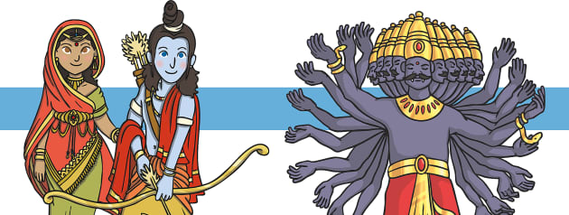
One day, the evil Ravana kidnapped Sita and took her away in his chariot. Clever Sita left a trail of her jewellery for Rama to follow. Rama and his brother, Lakshmana, followed the trail of glittering jewellery until they met the monkey king, Hanuman, who became their friend and agreed to help them to find Sita. Messages were sent to all the monkeys in the world who set out to find Sita.
After a very long search, Hanuman found Sita imprisoned on an island. Rama sent his army to fight a mighty battle army. The army of monkeys couldn’t reach the island so they began to build a bridge. Soon, all the animals of the world, large and small, came to help. When the bridge was built, they rushed across it and fought a mighty battle. Rama’s fighters and Hanuman’s army fought well and bravely.
Rama killed the evil Ravana with a magic arrow and the whole world rejoiced. Rama and Sita were reunited and they began their long journey back to their land. Everybody lit lamps to guide them on their way and welcome them back.
The story of Rama and Sita is one of the most well-known and popular stories in the Hindu religion.

Why is the story of Rama and Sita important?
The Rama and Sita story is so important because it teaches us about how good is more important than evil. There are also lessons of perseverance and commitment to those we care about. The story is also important because it features Rama, one of the avatars of Vishnu.
To this day, Hindus celebrate Diwali each autumn and light lamps to remember that light triumphs over darkness as good wins over evil.
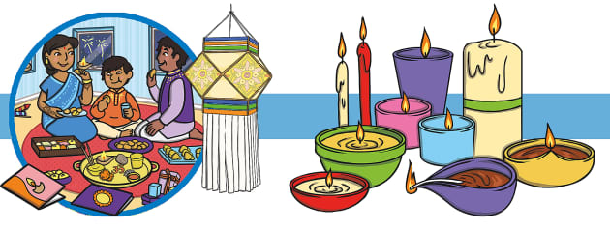
To learn more about the story of Rama and Sita, take a look at this PowerPoint that has more information. You can follow along with the slides straight from your screen too - so there's no need to print!
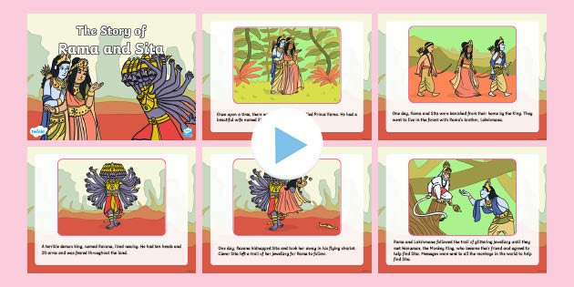
The Story of Rama and Sita PowerPoint

Hinduism Activities
- Create your own rangoli patterns.
- Make a Diwali light out of air-drying clay.
- Find India and the River Ganges on a map of the world.
- Create a storyboard to show the Hindu creation story.
- Play this creative and colourful interactive word mat game.
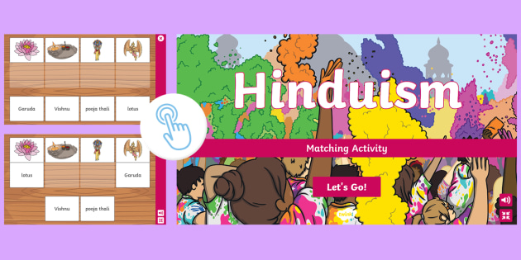
Hinduism Interactive Matching Activity

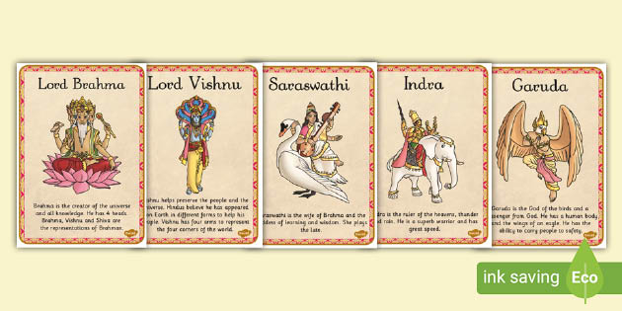
Hindu Gods Fact File Posters

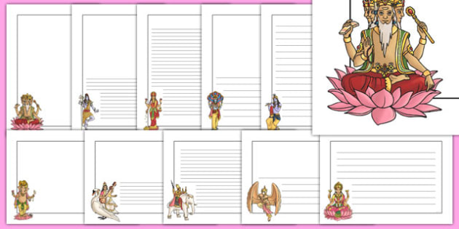
Hinduism Page Borders

Hindu Creation Story

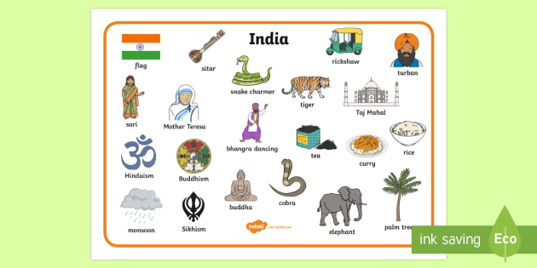
India Word Mat

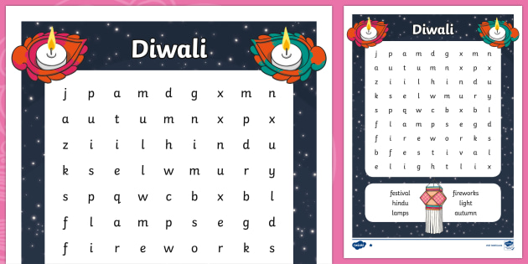
Diwali Word Search

Did you know..? We have lots of other fun activities for kids to try about other religions too! Take a look at our Religion Homework Help page for more topics.

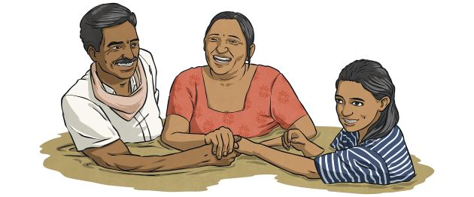
Now you can answer the question where do Hindus worship, why not find out more with this PowerPoint all about Hindu places of worship? It has lots of information that you can impress your teacher, family and friends with!
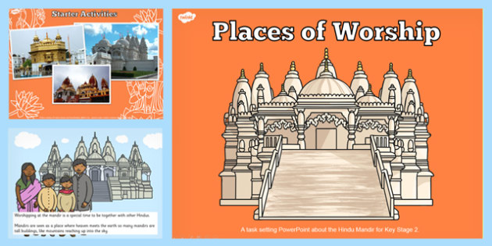
Places of Worship Hindu Mandirs KS2 PowerPoint

SOURCE AND COPYRIGHT: https://www.twinkl.com/

