

Hindu Basics

Nine Beliefs of Hinduism
February 6, 202017,800 views4 Comments
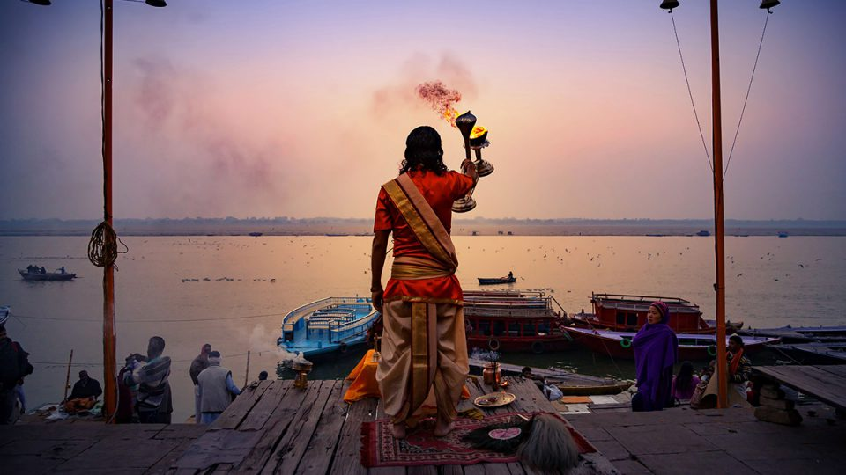
Our beliefs determine our thoughts and attitudes about life, which in turn direct our actions. By our actions, we create our destiny. Beliefs about sacred matters–God, soul and cosmos–are essential to one’s approach to life. Hindus believe many diverse things, but there are a few bedrock concepts on which most Hindus concur. The following nine beliefs, though not exhaustive, offer a simple summary of Hindu spirituality.
- Hindus believe in a one, all-pervasive Supreme Being who is both immanent and transcendent, both Creator and Unmanifest Reality.
- Hindus believe in the divinity of the four Vedas, the world’s most ancient scripture, and venerate the Agamas as equally revealed. These primordial hymns are God’s word and the bedrock of Sanatana Dharma, the eternal religion.
- Hindus believe that the universe undergoes endless cycles of creation, preservation and dissolution.
- Hindus believe in karma, the law of cause and effect by which each individual creates his own destiny by his thoughts, words and deeds.
- Hindus believe that the soul reincarnates, evolving through many births until all karmas have been resolved, and moksha, liberation from the cycle of rebirth, is attained. Not a single soul will be deprived of this destiny.
- Hindus believe that divine beings exist in unseen worlds and that temple worship, rituals, sacraments and personal devotionals create a communion with these devas and Gods.
- Hindus believe that an enlightened master, or satguru, is essential to know the Transcendent Absolute, as are personal discipline, good conduct, purification, pilgrimage, self-inquiry, meditation and surrender in God.
- Hindus believe that all life is sacred, to be loved and revered, and therefore practice ahimsa, noninjury, in thought, word and deed.
- Hindus believe that no religion teaches the only way to salvation above all others, but that all genuine paths are facets of God’s Light, deserving tolerance and understanding.
Hinduism, the world’s oldest religion, has no beginning–it precedes recorded history. It has no human founder. It is a mystical religion, leading the devotee to personally experience the Truth within, finally reaching the pinnacle of consciousness where man and God are one. Hinduism has four main denominations–Saivism, Shaktism, Vaishnavism and Smartism.
Browsing Tag

Temples

April/May/June, 2022 Feature Stories

The Wondrous Wood Temples of Tons Valley
Trek the highlands to the sacred masterpieces along the Tons River as it flows…
March 31, 2022
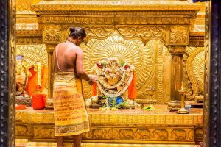
January/February/March, 2022 Temples & Pilgrimage Hindu Priesthood Philosophy & Scripture

The Ancient Agamas Have Solutions for Modern Issues in Temple Administration
These detailed manuals cover everything from how to build temples to the worship rituals…
January 1, 2022

October/November/December, 2021 Temples & Pilgrimage Feature Stories

Unusual Temples & Shrines of India
A Special Feature BY ANURADHA GOYAL Every hindu temple is a home of its…
October 1, 2021

July/August/September, 2021 Temples & Pilgrimage

Famed Kerala Temple Wins Supreme Court Decision
After a decade, trusteeship of this fabulously wealthy temple of Lord Vishnu has finally…
July 1, 2021

October/November/December, 2020

Global Dharma
UNITED STATES Children Honor Their Teachers the Hindu Way By Dinesh R. Pai Inculcating…
October 1, 2020
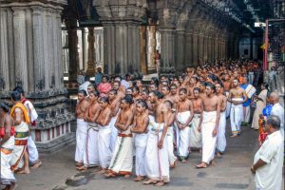
October/November/December, 2020 Temples & Pilgrimage Hindu Priesthood

Our 2020 Hindus of the Year
Chidambaram’s Dikshitar priests have faithfully served the temple for over two millennia By Choodie…
October 1, 2020

Temples & Pilgrimage April/May/June, 2020

Feature: Nepal’s Revered Pashupatinath Temple
Pashupatinath, by far Nepal’s most popular temple, dates back to at least the 1st…
April 1, 2020

Hindu Basics

Nine Beliefs of Hinduism
Our beliefs determine our thoughts and attitudes about life, which in turn direct our…
February 6, 2020
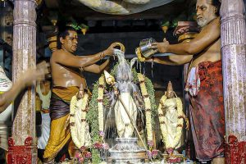
January/February/March, 2020 Educational Resources

Insight: Hinduism, the Greatest Religion in the World
A satguru’s unequivocating insights on the Earth’s oldest living faith FROM THE TEACHINGS OF…
January 1, 2020
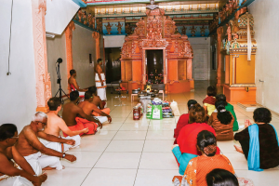
Temples & Pilgrimage January/February/March, 2020

Malaysia: A Visit to Amma Lucy’s Siva Temple
A psychic Chinese girl in Malaysia grew up loving all things Indian/Hindu. Following her…
January 1, 2020
Browsing Tag

Scripture
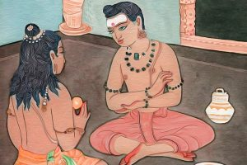
January/February/March, 2022 Philosophy & Scripture

Comprehending Comprehension
A father’s advice to a son eager for spiritual mastery The following is a…
January 1, 2022
January/February/March, 2022 Temples & Pilgrimage Hindu Priesthood Philosophy & Scripture

The Ancient Agamas Have Solutions for Modern Issues in Temple Administration
These detailed manuals cover everything from how to build temples to the worship rituals…
January 1, 2022
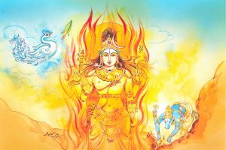
October/November/December, 2021 Philosophy & Scripture

You Are All Things
A Vedic reflection on That which is in and through all existence The following…
October 1, 2021
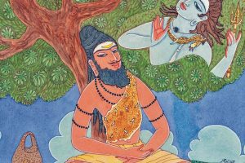
July/August/September, 2021 Philosophy & Scripture

Divine Coalescence
A rishi’s rhapsody on the yogic path of complete union in God The following…
July 1, 2021
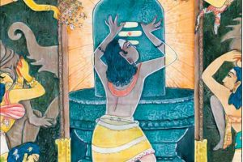
April/May/June, 2021 Philosophy & Scripture

From the Upanishads: At Life’s End
Vedic elucidations on the natural transition from human life The following is a translation…
April 1, 2021
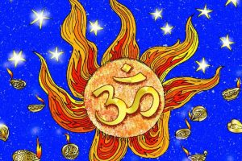
July/August/September, 2020 Philosophy & Scripture

What Is the Primal Cause?
From the Upanishads Reflections on the subtle origins of existence, resident within us all…
September 6, 2020
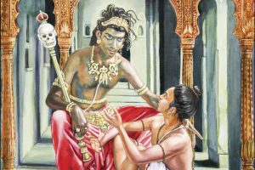
April/May/June, 2020 Philosophy & Scripture

From the Upanishads: Lord Yama Illustrates the Absolute
The God of Death reveals the mysteries of the one true Self in all.…
April 1, 2020
Hindu Basics

Nine Beliefs of Hinduism
Our beliefs determine our thoughts and attitudes about life, which in turn direct our…
February 6, 2020
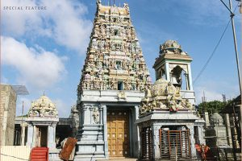
Magazine Temples & Pilgrimage January/February/March, 2020

Tiruketheeswaram Temple
Four hundred years after its destruction, the temple extolled by the ancient Tamil saints…
January 1, 2020
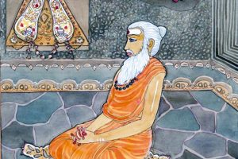
Magazine October/November/December, 2019 Philosophy & Scripture

From the Kularnava Tantra
An elucidation upon the impermanence and bondage of earthly life and the compelling need…
October 1, 2019

Basics

Hindu Basics

Hinduism: An Overview
Hinduism, also known as the Sanatana Dharma, or “Eternal Way,” is our planet’s original…
February 6, 2020
Hindu Basics

Nine Beliefs of Hinduism
Our beliefs determine our thoughts and attitudes about life, which in turn direct our…
February 6, 2020
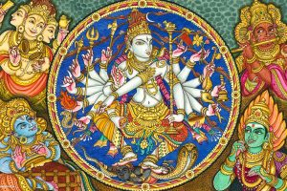
January/February/March, 2022 Hindu Basics

14 Frequently Asked Questions
Question One: Why does Hinduism have so many Gods? A: Hindus all believe in one…
February 6, 2020
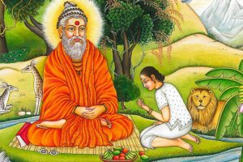
Hindu Basics

Hinduism’s Four Denominations
For over 200 years, Western scholars have struggled to understand Hinduism, a faith whose…
February 6, 2020
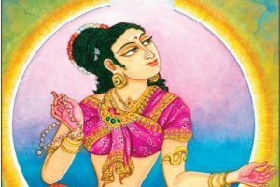
Hindu Basics

How to Formally Enter Hinduism
Ask Yourself the Question: “Are You a Hindu?” Belief is the keynote of religious…
March 2, 2016

Browsing Tag

Karma

Publisher's Editorials April/May/June, 2020

Pubisher’s Desk: Integrating Hinduism into Daily Tasks
No need to wait for personal time for spiritual practices. You can do inner…
April 1, 2020
Hindu Basics

Nine Beliefs of Hinduism
Our beliefs determine our thoughts and attitudes about life, which in turn direct our…
February 6, 2020
January/February/March, 2022 Hindu Basics

14 Frequently Asked Questions
Question One: Why does Hinduism have so many Gods? A: Hindus all believe in one…
February 6, 2020
January/February/March, 2020 Educational Resources

Insight: Hinduism, the Greatest Religion in the World
A satguru’s unequivocating insights on the Earth’s oldest living faith FROM THE TEACHINGS OF…
January 1, 2020
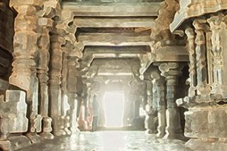
Hindu Basics

Karma and Reincarnation
Insights on Two Fundamental Hindu Concepts From the Teachings of Sivaya Subramuniyaswami Our wise…
September 5, 2019
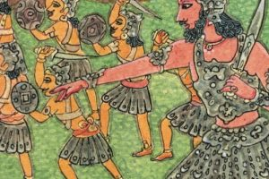
Publisher's Editorials July/August/September, 2014

Publisher’s Desk: Noninjury: the Foremost Virtue
______________________ Belief in the law of karma and accepting the divinity of all beings…
July 1, 2014

July/August/September, 2005

Transplanting Karmas
BY MARK HAWTHORNE When she awoke from a heart and double-lung transplant operation at…
July 1, 2005
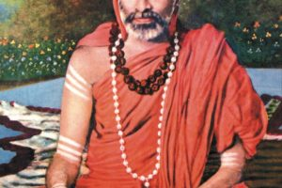
April/May/June, 2004

Master Your Destiny!
His Holiness Sri Chandrashekara Bharati Mahaswami, 1892-1954, was the Sankaracharya of Sringeri Peetha for…
April 1, 2004

January/February/March, 2004

Karma and Gravity
BY ARVIND SHARMA Karma is a key Hindu concept not always easily explained. Comparing…
January 1, 2004

October/November/December, 2002

Karma Management
The concept of karma has spread beyond the confines of the Asian religions that…
October 1, 2002

Browsing Tag

Reincarnation
Hindu Basics

Nine Beliefs of Hinduism
Our beliefs determine our thoughts and attitudes about life, which in turn direct our…
February 6, 2020
January/February/March, 2022 Hindu Basics

14 Frequently Asked Questions
Question One: Why does Hinduism have so many Gods? A: Hindus all believe in one…
February 6, 2020
Hindu Basics

Karma and Reincarnation
Insights on Two Fundamental Hindu Concepts From the Teachings of Sivaya Subramuniyaswami Our wise…
September 5, 2019

July/August/September, 2019 Educational Resources

Educational Insight: Hinduism In a Nutshell
A Simple Overview of a Complex Faith BY THE EDITORS, DRAWN FROM THE TEACHINGS…
July 1, 2019
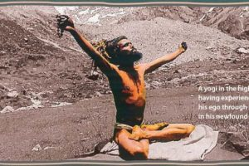
Magazine July/August/September, 2018

How Enlightened Beings Die
Ten Stories of the Final Moments of Great Sages & Ten Reasons Hindus Do…
July 1, 2018

January/February/March, 2007

Death and Dying
The Hindu view of the grand departure and it’s sacred rites of passage “Lead…
January 1, 2007
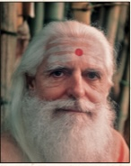
July/August/September, 2002

Revenge Is a Terrible Negative Force
By Satguru Sivaya Subramuniyaswami If we act wrongly toward others, people will act wrongly…
July 1, 2002

Browsing Tag

God and Gods
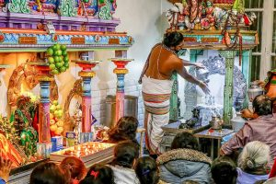
April/May/June, 2021 Publisher's Editorials

Essential Ingredients for a Powerful Puja
Pondering the mystical elements and knowledge behind Hinduism’s major form of temple worship By…
April 1, 2021
April/May/June, 2020 Philosophy & Scripture

From the Upanishads: Lord Yama Illustrates the Absolute
The God of Death reveals the mysteries of the one true Self in all.…
April 1, 2020
Hindu Basics

Hinduism: An Overview
Hinduism, also known as the Sanatana Dharma, or “Eternal Way,” is our planet’s original…
February 6, 2020
Hindu Basics

Nine Beliefs of Hinduism
Our beliefs determine our thoughts and attitudes about life, which in turn direct our…
February 6, 2020
January/February/March, 2022 Hindu Basics

14 Frequently Asked Questions
Question One: Why does Hinduism have so many Gods? A: Hindus all believe in one…
February 6, 2020

Browsing Tag

Vedas
October/November/December, 2021 Philosophy & Scripture

You Are All Things
A Vedic reflection on That which is in and through all existence The following…
October 1, 2021
April/May/June, 2021 Philosophy & Scripture

From the Upanishads: At Life’s End
Vedic elucidations on the natural transition from human life The following is a translation…
April 1, 2021
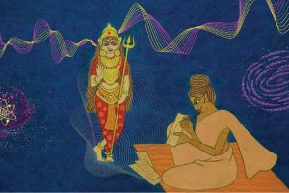
January/February/March, 2021 Educational Resources Saints & Sages

Educational Insight: Seven Indian Women Luminaries
Celebrating the life, virtues and spirituality of a few of Bharat’s remarkable Hindu women…
January 1, 2021
July/August/September, 2020 Philosophy & Scripture

What Is the Primal Cause?
From the Upanishads Reflections on the subtle origins of existence, resident within us all…
September 6, 2020
Hindu Basics

Nine Beliefs of Hinduism
Our beliefs determine our thoughts and attitudes about life, which in turn direct our…
February 6, 2020

Magazine October/November/December, 2019

Global Dharma
Youth Time to Get Woke IN LATE MAY OF 2019, STUDENTS and young professionals…
October 1, 2019
Philosophy & Scripture April/May/June, 2019

From the Vedas: Knowers of Brahman
The Shvetashvatara Upanishad Describes the One All-Pervading Being The following is an excerpt from…
April 1, 2019

Magazine July/August/September, 2019

From the Vedas: In Tribute to Knowledge and Lack of Desire
The bliss of one well-versed in the Vedas surpasses that of the higher beings The following…
April 1, 2019
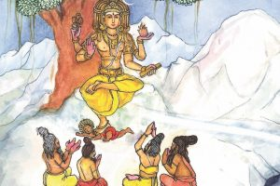
Philosophy & Scripture October/November/December, 2014

From The Agamas: Revealing Scripture
FROM THE AGAMAS REVEALING SCRIPTURE ______________________ An esoteric introduction to the Mrigendra Agama unveiled…
October 1, 2014
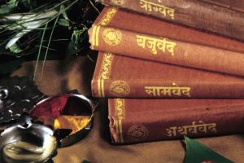
Philosophy & Scripture July/August/September, 2006

Hindu Scriptures
The Word, verily, is greater than name. The Word, in fact, makes known the…
July 1, 2006
Browsing Tag

Nonviolence

Hindu Basics

Nine Beliefs of Hinduism
Our beliefs determine our thoughts and attitudes about life, which in turn direct our…
February 6, 2020

Publisher's Editorials April/May/June, 2007

Hinduism and Modern Life
Some months back in Australia, a group of Hindu teens asked me what relevance…
April 1, 2007

January/February/March, 2007

Ahimsa: To Do No Harm
We Can Change the Way Mankind Behaves by Practicing Nonviolence BY SATGURU SIVAYA SUBRAMUNIYASWAMI…
January 1, 2007

April/May/June, 2003

Champions of Nonviolence
By Mark Hawthorne Here are in the world many people who have fought great…
April 1, 2003
Hindu Basics

Hinduism: An Overview
February 6, 20207,552 views 1 Comment
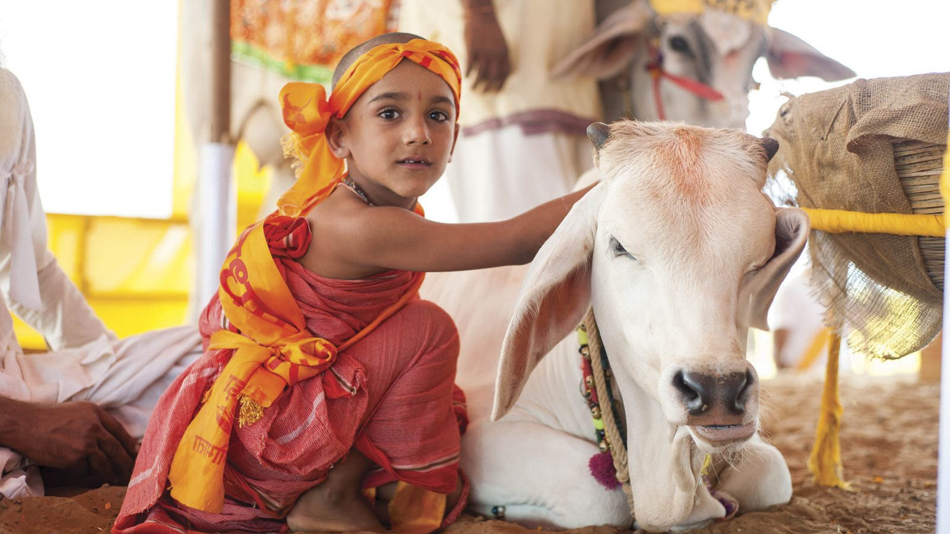
Hinduism, also known as the Sanatana Dharma, or “Eternal Way,” is our planet’s original and oldest living religion, with over one billion adherents. Today it has four main denominations: Saivism, Shaktism, Vaishnavism and Smartism, each with hundreds of lineages. They represent a broad range of beliefs, practices and mystic goals, but virtually all concur on certain bedrock concepts.
All Hindus worship one Supreme Reality, though they call it by many names. There is no eternal hell, no damnation, in Hinduism, and no intrinsic evil—no satanic force that opposes the will of God. Hindus believe that the cosmos was created out of God and is permeated by Him/Her—a Supreme Being who both is form and pervades form, who creates, sustains and destroys the universe only to recreate it again in unending cycles. Each soul is free to find their own way, whether by devotion, austerity, meditation, yoga or selfless service.
A young women performs a worshipful dance at the Mukteshvara Temple in Odisha, India
Hinduism’s three pillars are temple worship, scripture and the guru-disciple tradition. Hinduism strongly declares the validity of the three worlds of existence—physical, astral and spiritual–and the myriad Gods and devas residing within the inner worlds. Festivals, pilgrimage, chanting of holy hymns and home worship are dynamic practices. Family life is strong and precious. Love, nonviolence, good conduct and the law of dharma define the Hindu path.
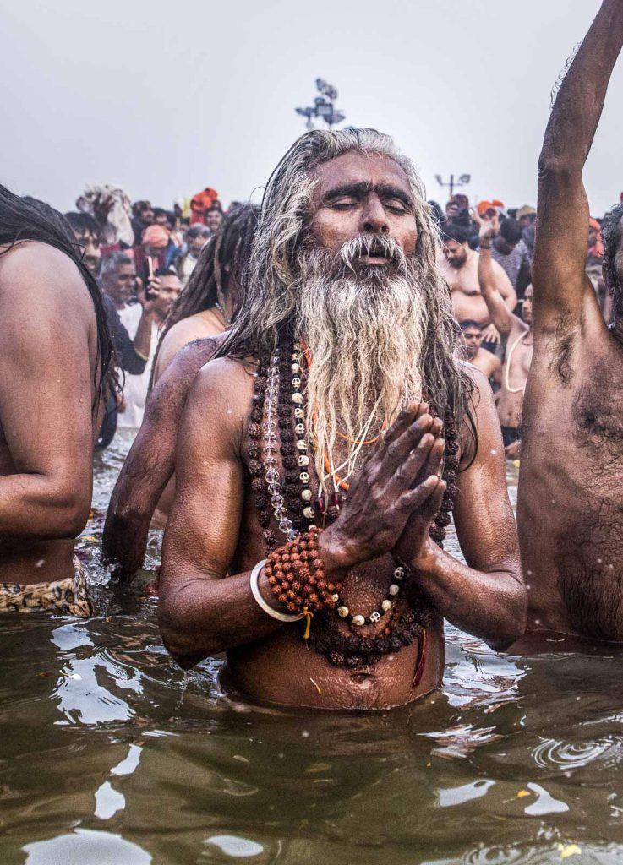A holy man worships God within, during the 2019 Kumbh Mela—a major Hindu festival in India
Hindus are generously tolerant of other faiths. Hinduism explains that the soul reincarnates until all karmas are resolved and God Realization is attained. All souls, without exception, will attain this highest spiritual summit, though it may take many lives. This is a mystical religion, leading devotees to personally experience its eternal truths within themselves, finally reaching the pinnacle of consciousness where man and God are forever one.
Hindus prefer cremation of the body upon death, rather than burial, believing that the soul lives on and will inhabit a new body on Earth.
While we have many sacred scriptures, all sects ascribe the highest authority to the Vedas and Agamas. Hinduism has tens of thousands of holy temples and shrines, mostly in India, but now located around the world. Its spiritual core is its holy men and women who have dedicated their lives to full-time service, devotion and God Realization, and to proclaiming the eternal truths of the Sanatana Dharma.
For a quick visual introduction, see Part 1 of our History of Hindu India:

Post Views: 5,423
Meditation Yoga Worship Basics Dharma God and Gods Hinduism Self Realization

